1. Count the number of identities(Aadhaar) generated in each state?

import java.io.IOException;
import org.apache.hadoop.conf.Configuration;
import org.apache.hadoop.fs.FileSystem;
import org.apache.hadoop.fs.Path;
import org.apache.hadoop.io.IntWritable;
import org.apache.hadoop.io.LongWritable;
import org.apache.hadoop.io.Text;
import org.apache.hadoop.mapreduce.Job;
import org.apache.hadoop.mapreduce.Mapper;
import org.apache.hadoop.mapreduce.Reducer;
import org.apache.hadoop.mapreduce.lib.input.FileInputFormat;
import org.apache.hadoop.mapreduce.lib.output.FileOutputFormat;

public class techm1 {
public static class Mymapper extends Mapper<LongWritable,Text,Text,Text>{
public void map(LongWritable key,Text value,Context context) throws IOException, InterruptedException{
String arr[]=value.toString().split(",");
if(arr[8].equals("1"))
context.write(new Text(arr[2]), new Text(arr[8]));
}
}
public static class Myreducer extends Reducer<Text,Text,Text,IntWritable>
{

public void reduce(Text key,Iterable<Text> value,Context context) throws IOException, InterruptedException{
int count=0;
for(Text a:value)
{
i=Integer.parseInt(a.toString());

count++;

}
context.write(key,new IntWritable(count));
}
}
public static void main(String args[]) throws ClassNotFoundException, IOException, InterruptedException{
Configuration conf=new Configuration();
Job job=Job.getInstance(conf,"work");
job.setJarByClass(deloitte.class);

job.setMapperClass(Mymapper.class);
job.setReducerClass(Myreducer.class);

job.setMapOutputKeyClass(Text.class);
job.setMapOutputValueClass(Text.class);

job.setOutputKeyClass(Text.class);
job.setOutputValueClass(IntWritable.class);

FileSystem.get(conf).delete(new Path(args[1]),true);
FileInputFormat.addInputPath(job, new Path(args[0]));
FileOutputFormat.setOutputPath(job,new Path(args[1]));

System.exit(job.waitForCompletion(true)?0:1);

}
}

This output is Count of aadhad generated by each state.
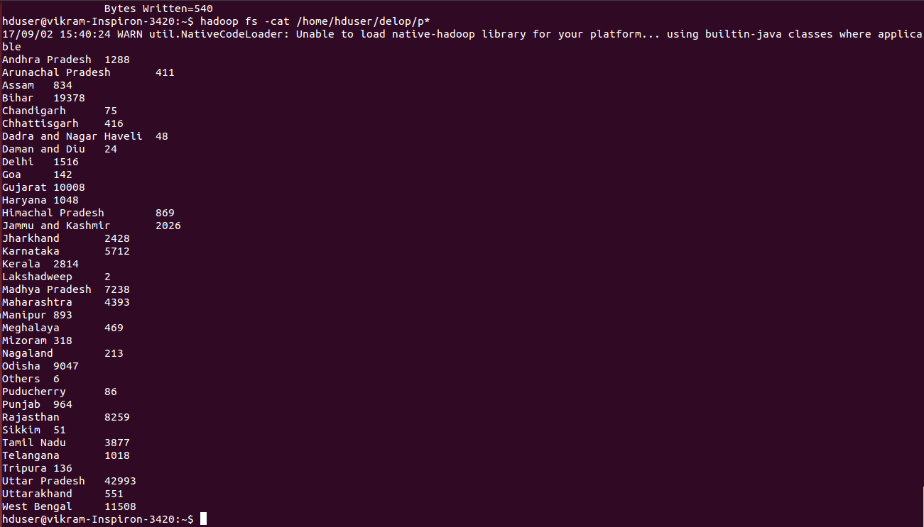

2. Count the number of identities generated by each Enrolment Agency?

import java.io.IOException;

import org.apache.hadoop.conf.Configuration;
import org.apache.hadoop.fs.FileSystem;
import org.apache.hadoop.fs.Path;
import org.apache.hadoop.io.IntWritable;
import org.apache.hadoop.io.LongWritable;
import org.apache.hadoop.io.Text;
import org.apache.hadoop.mapreduce.Job;
import org.apache.hadoop.mapreduce.Mapper;
import org.apache.hadoop.mapreduce.Reducer;
import org.apache.hadoop.mapreduce.lib.input.FileInputFormat;
import org.apache.hadoop.mapreduce.lib.output.FileOutputFormat;

public class techm2 {
public static class Mymapper extends Mapper<LongWritable,Text,Text,Text>{
public void map(LongWritable key,Text value,Context context) throws IOException, InterruptedException{
String arr[]=value.toString().split(",");
if(arr[8].equals("1"))
context.write(new Text(arr[1]), new Text(arr[8]));
}
}
public static class Myreducer extends Reducer<Text,Text,Text,IntWritable>
{

public void reduce(Text key,Iterable<Text> value,Context context) throws IOException, InterruptedException{
int count=0;
for(Text a:value)
{
count++;

}
context.write(key,new IntWritable(count));
}
}
public static void main(String args[]) throws ClassNotFoundException, IOException, InterruptedException{
Configuration conf=new Configuration();
Job job=Job.getInstance(conf,"work");
job.setJarByClass(techm2.class);

job.setMapperClass(Mymapper.class);
job.setReducerClass(Myreducer.class);

job.setMapOutputKeyClass(Text.class);
job.setMapOutputValueClass(Text.class);

job.setOutputKeyClass(Text.class);
job.setOutputValueClass(IntWritable.class);

FileSystem.get(conf).delete(new Path(args[1]),true);
FileInputFormat.addInputPath(job, new Path(args[0]));
FileOutputFormat.setOutputPath(job,new Path(args[1]));

System.exit(job.waitForCompletion(true)?0:1);

}
}

----- This output is Count of the aadhar cards generated by each Agency.
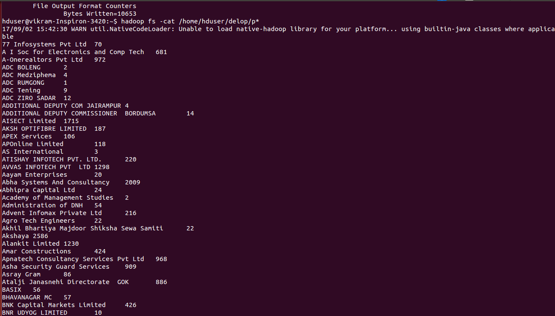
3. Find Top 10 districts with maximum identities generated for both Male and Female?

import java.io.IOException;
import java.util.TreeMap;

import org.apache.hadoop.conf.Configuration;
import org.apache.hadoop.fs.FileSystem;
import org.apache.hadoop.fs.Path;
import org.apache.hadoop.io.LongWritable;
import org.apache.hadoop.io.NullWritable;
import org.apache.hadoop.io.Text;
import org.apache.hadoop.mapreduce.Job;
import org.apache.hadoop.mapreduce.Mapper;
import org.apache.hadoop.mapreduce.Reducer;
import org.apache.hadoop.mapreduce.lib.input.FileInputFormat;
import org.apache.hadoop.mapreduce.lib.output.FileOutputFormat;

public class techm3 {
public static class Mymapper extends Mapper<LongWritable,Text,Text,Text>{
public void map(LongWritable key,Text value,Context context) throws IOException, InterruptedException{
String arr[]=value.toString().split(",");
String s=arr[3]+" "+arr[6];
if(arr[6].contains("M"))
if(arr[8].contains("1"))
context.write(new Text(s), new Text(arr[8]));
}
}
public static class Myreducer extends Reducer<Text,Text,NullWritable,Text>
{
TreeMap<Integer, Text> tm=new TreeMap<Integer, Text>();
public void reduce(Text key,Iterable<Text> value,Context context) throws IOException, InterruptedException{
String k=key.toString();
String kk="";
int count=0;

for(Text a:value){
count++;
kk=k+" "+count;
}
tm.put(count,new Text(kk));
if(tm.size()>10)
{
tm.remove(tm.firstKey());
}
}

public void cleanup(Context context) throws IOException, InterruptedException
{
for(Text b:tm.descendingMap().values())
context.write(NullWritable.get(),b);
}}
public static void main(String args[]) throws ClassNotFoundException, IOException, InterruptedException{
Configuration conf=new Configuration();
Job job=Job.getInstance(conf,"work");
job.setJarByClass(techm3.class);

job.setMapperClass(Mymapper.class);
job.setReducerClass(Myreducer.class);
job.setMapOutputKeyClass(Text.class);
job.setMapOutputValueClass(Text.class);
job.setOutputKeyClass(NullWritable.class);
job.setOutputValueClass(Text.class);
FileSystem.get(conf).delete(new Path(args[1]),true);
FileInputFormat.addInputPath(job, new Path(args[0]));
FileOutputFormat.setOutputPath(job,new Path(args[1]));
System.exit(job.waitForCompletion(true)?0:1);
}
}
==================top 10 districts for Male============
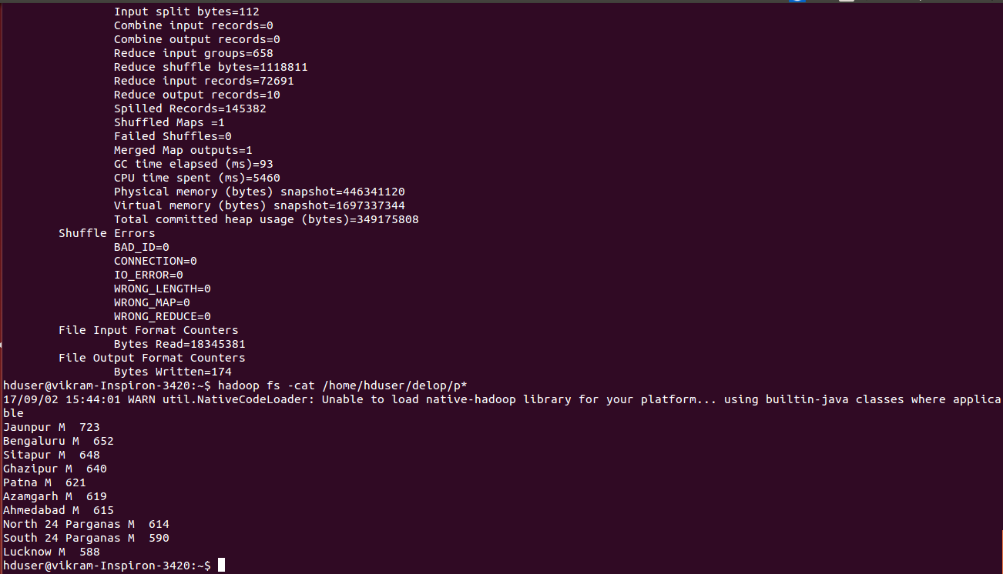
===================top 10 districts for female=========
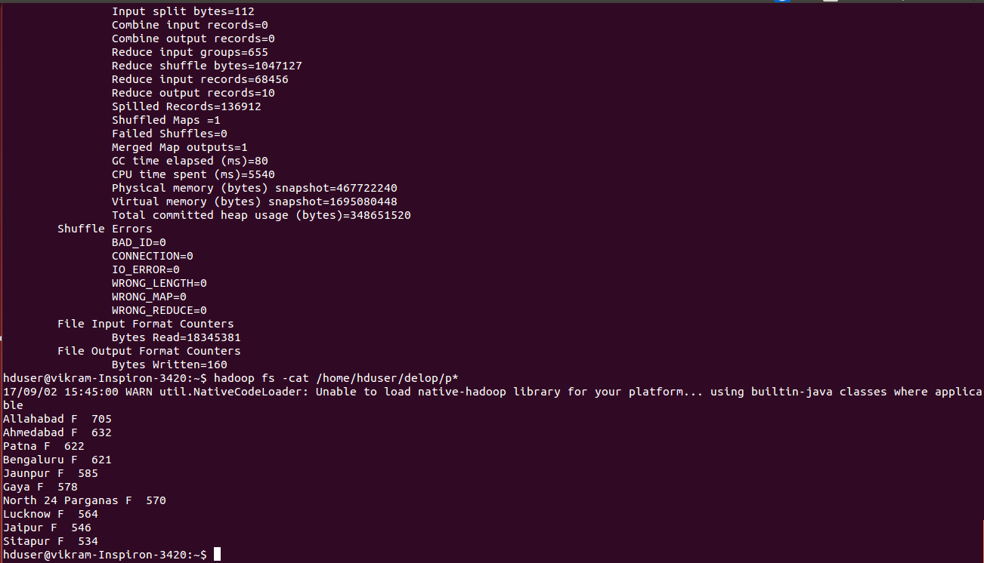
4. Find out the total number of cards rejected by states?

import java.io.IOException;
import org.apache.hadoop.conf.Configuration;
import org.apache.hadoop.fs.FileSystem;
import org.apache.hadoop.fs.Path;
import org.apache.hadoop.io.IntWritable;
import org.apache.hadoop.io.LongWritable;
import org.apache.hadoop.io.Text;
import org.apache.hadoop.mapreduce.Job;
import org.apache.hadoop.mapreduce.Mapper;
import org.apache.hadoop.mapreduce.Reducer;
import org.apache.hadoop.mapreduce.lib.input.FileInputFormat;
import org.apache.hadoop.mapreduce.lib.output.FileOutputFormat;

public class techm4 {
public static class Mymapper extends Mapper<LongWritable,Text,Text,Text>{
public void map(LongWritable key,Text value,Context context) throws IOException, InterruptedException{
String arr[]=value.toString().split(",");
if(arr[8].equals("0"))
context.write(new Text(arr[2]), new Text(arr[8]));
}
}
public static class Myreducer extends Reducer<Text,Text,Text,IntWritable>
{

public void reduce(Text key,Iterable<Text> value,Context context) throws IOException, InterruptedException{
int count=0;
for(Text a:value)
{
count++;

}
context.write(key,new IntWritable(count));
}
}
public static void main(String args[]) throws ClassNotFoundException, IOException, InterruptedException{
Configuration conf=new Configuration();
Job job=Job.getInstance(conf,"work");
job.setJarByClass(techm4.class);

job.setMapperClass(Mymapper.class);
job.setReducerClass(Myreducer.class);

job.setMapOutputKeyClass(Text.class);
job.setMapOutputValueClass(Text.class);

job.setOutputKeyClass(Text.class);
job.setOutputValueClass(IntWritable.class);

FileSystem.get(conf).delete(new Path(args[1]),true);
FileInputFormat.addInputPath(job, new Path(args[0]));
FileOutputFormat.setOutputPath(job,new Path(args[1]));

System.exit(job.waitForCompletion(true)?0:1);

}
}

This is the output for number of aadhar cards rejected by each states.

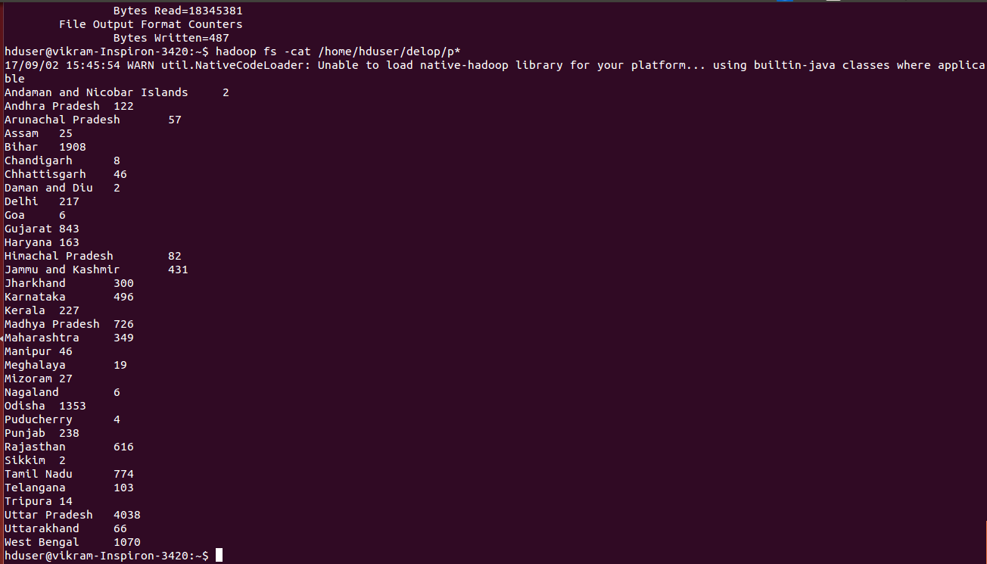
5. Find out the age groups with their respective number of identities?
import java.io.IOException;

import org.apache.hadoop.conf.Configuration;
import org.apache.hadoop.fs.FileSystem;
import org.apache.hadoop.fs.Path;
import org.apache.hadoop.io.IntWritable;
import org.apache.hadoop.io.LongWritable;
import org.apache.hadoop.io.Text;
import org.apache.hadoop.mapreduce.Job;
import org.apache.hadoop.mapreduce.Mapper;
import org.apache.hadoop.mapreduce.Reducer;
import org.apache.hadoop.mapreduce.lib.input.FileInputFormat;
import org.apache.hadoop.mapreduce.lib.output.FileOutputFormat;

public class techm5 {
public static class Mymapper extends Mapper<LongWritable,Text,IntWritable,Text>{
public void map(LongWritable key,Text value,Context context) throws IOException, InterruptedException{
String arr[]=value.toString().split(",");
int i=Integer.parseInt(arr[7].toString());
if(arr[8].equals("1"))
context.write(new IntWritable(i), new Text(arr[8]));
}
}
public static class Myreducer extends Reducer<IntWritable,Text,IntWritable,IntWritable>
{

public void reduce(IntWritable key,Iterable<Text> value,Context context) throws IOException, InterruptedException{
int count=0;
for(Text a:value)
{
count++;

}
context.write(key,new IntWritable(count));
}
}
public static void main(String args[]) throws ClassNotFoundException, IOException, InterruptedException{
Configuration conf=new Configuration();
Job job=Job.getInstance(conf,"work");
job.setJarByClass(techm5.class);

job.setMapperClass(Mymapper.class);
job.setReducerClass(Myreducer.class);

job.setMapOutputKeyClass(IntWritable.class);
job.setMapOutputValueClass(Text.class);

job.setOutputKeyClass(IntWritable.class);
job.setOutputValueClass(IntWritable.class);

FileSystem.get(conf).delete(new Path(args[1]),true);
FileInputFormat.addInputPath(job, new Path(args[0]));
FileOutputFormat.setOutputPath(job,new Path(args[1]));
System.exit(job.waitForCompletion(true)?0:1);

}
}
This output is the Count of the aadhar cards with respective to the age groups

